Country.java
package orm_learn.model;
import jakarta.persistence.Column;
import jakarta.persistence.Entity;
import jakarta.persistence.Id;
import jakarta.persistence.Table;

@Entity
@Table(name = "country")
public class Country {

@Id
@Column(name = "code")
private String code;

@Column(name = "name")
private String name;

public Country() {
}

public String getCode() {
return code;
}

public void setCode(String code) {
this.code = code;
}

public String getName() {
return name;
}

public void setName(String name) {
this.name = name;
}

@Override
public String toString() {
return "Country [code=" + code + ", name=" + name + "]";
}
}
Countryrepository.java
@Column(name = "name")
private String name;

public Country() {
}

public String getCode() {
return code;
}

public void setCode(String code) {
this.code = code;
}

public String getName() {
return name;
}

public void setName(String name) {
this.name = name;
}

@Override
public String toString() {
return "Country [code=" + code + ", name=" + name + "]";
}
}
Countryrepository.java
package orm_learn.service;

import java.util.List;

import org.springframework.beans.factory.annotation.Autowired;
import org.springframework.stereotype.Service;

import jakarta.transaction.Transactional;
import orm_learn.model.Country;
import orm_learn.repository.CountryRepository;

@Service
public class CountryService {

@Autowired
private CountryRepository countryRepository;

@Transactional
public List<Country> getAllCountries() {
return countryRepository.findAll();
}
}
Sql
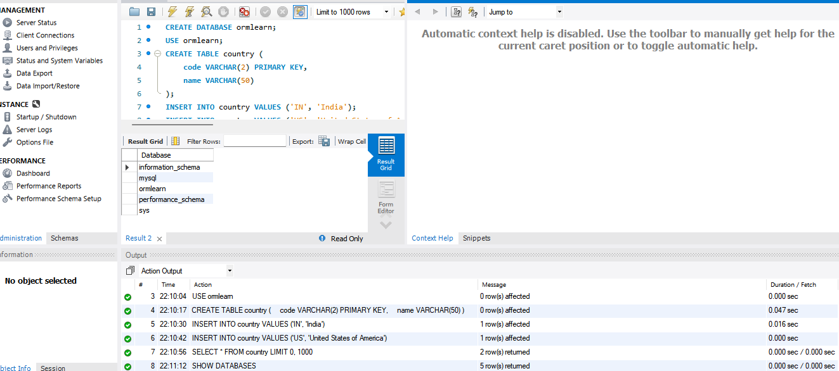

Exercise-2
package orm_learn;

import org.slf4j.Logger;
import org.slf4j.LoggerFactory;
import org.springframework.boot.SpringApplication;
import org.springframework.boot.autoconfigure.SpringBootApplication;
import org.springframework.context.ApplicationContext;

import orm_learn.model.Employee;
import orm_learn.service.EmployeeService;

@SpringBootApplication
public class OrmLearnApplication {

private static final Logger LOGGER =
LoggerFactory.getLogger(OrmLearnApplication.class);

private static EmployeeService employeeService;

public static void main(String[] args) {

ApplicationContext context =
SpringApplication.run(OrmLearnApplication.class, args);

employeeService = context.getBean(EmployeeService.class);

LOGGER.info("Inside Main");

testAddEmployee();
}

private static void testAddEmployee() {

LOGGER.info("Start");

Employee employee = new Employee(101, "Vinitha", 50000);

employeeService.addEmployee(employee);

LOGGER.info("Employee Added Successfully");

LOGGER.info("End");
}
}

Employee.java
package orm_learn.model;

import jakarta.persistence.Entity;
import jakarta.persistence.Id;
import jakarta.persistence.Table;

@Entity
@Table(name="employee")
public class Employee {

@Id
private int id;

private String name;

private double salary;

public Employee() {
}

public Employee(int id, String name, double salary) {
this.id = id;
this.name = name;
this.salary = salary;
}

public int getId() {
return id;
}

public void setId(int id) {
this.id = id;
}

public String getName() {
return name;
}

public void setName(String name) {
this.name = name;
}

public double getSalary() {
return salary;
}

public void setSalary(double salary) {
this.salary = salary;
}
}
Employeerepository.java
package orm_learn.repository;

import org.springframework.data.jpa.repository.JpaRepository;
import org.springframework.stereotype.Repository;

import orm_learn.model.Employee;

@Repository
public interface EMployeeRepository extends JpaRepository<Employee,Integer>{

}
Employeerepository.java
package orm_learn.service;

import org.springframework.beans.factory.annotation.Autowired;
import org.springframework.stereotype.Service;

import jakarta.transaction.Transactional;
import orm_learn.model.Employee;
import orm_learn.repository.EMloyeeRepository;

@Service
public class EmployeeService {

@Autowired
private EMployeeRepository employeeRepository;

@Transactional
public void addEmployee(Employee employee) {

employeeRepository.save(employee);

}
}

Output
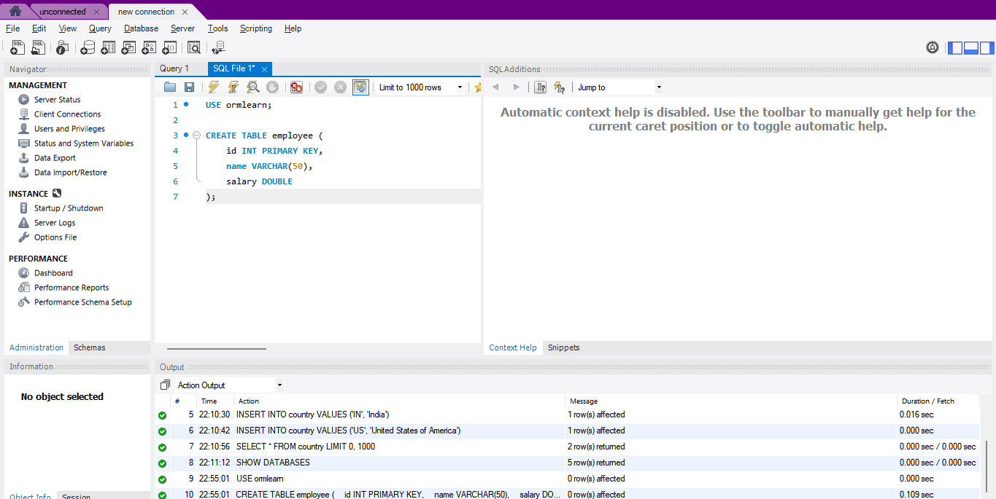s

